MINISTRY OF EDUCATION AND SCIENCE OF THE REPUBLIC OF KAZAKHSTAN

INTERNATIONAL INFORMATION TECHNOLOGY UNIVERSITY

FACULTY OF INFORMATION TECHNOLOGIES

DEPARTMENT OF COMPUTER ENGINEERING AND TELECOMMUNICATIONS

BookStore

Major 5B070400 – Computer systems and software engineering

Discipline Web technologies

STUDENT(S): CSSE-1501k

Aksakalov Beksultan

Rasylkhan Adilet

Utemisov Ersultan _________

(Group and student name) (Signature)

SUPERVISOR: Assistant-professor

Mukazhanov N.K. _________

(Position, name) (Signature)

Almaty 2018

Content

Introduction

Main part

1. Description

2. Theoretical part

§ Architecture

§ Sitemap

§ Wireframe

§ Web design

§ Database models

§ Short description for each entity

3. Creation

* Web pages

* Server scripts

* Creation of web database

4. Conclusion

5. References

**Introduction**

This report include the process of developing the project “BookStore”

Here you can find all the necessary descriptions for this project. The description of the project, the design of the project including the architecture of construction, sitemap, wireframe drawings, web design, database models. The development process is also provided: project web pages, various scripts connecting to the server for project integration and database development. In addition, the result of the project with output and the materials used.

**Main part**

1. Theoretical part

The business-to-consumer aspect of electronic commerce (e-commerce) is the most visible business use of the World Wide Web. The primary goal of an e-commerce site is to sell goods and services online.

This project deals with developing an e-commerce website for Online Book Sale. It provides the user with a catalog of different books available for purchase in the store. In order to facilitate online purchase a shopping cart is provided to the user.

This is a project with the objective to develop a basic website where a consumer is provided with a shopping cart application and also to know about the technologies used to develop such an application.

And in our Lab we used HTML and CSS markup languages to create our work. Lab consists of 8 pages:

* Mainpage
* Contacts
* About us
* Sign up or sign in
* FAQ
* New coming
* Best sellers
* Cart

**PHP** is a server-side scripting language designed for web development but also used as a general-purpose programming language. It was originally created by Rasmus Lerdorf in 1994, the PHP reference implementation is now produced by The PHP Group. PHP originally stood for Personal Home Page, but it now stands for the recursive acronym PHP: Hypertext Preprocessor.

Also, PHP is a popular general-purpose scripting language that is especially suited to web development.

Fast, flexible and pragmatic, PHP powers everything from your blog to the most popular websites in the world.

**Bootstrap** is a free and open-source front-end library for designing websites and web applications. It contains HTML- and CSS-based design templates for typography, forms, buttons, navigation and other interface components, as well as optional JavaScript extensions. Unlike many web frameworks, it concerns itself with front-end development only.

1. Design

* Architecture of website

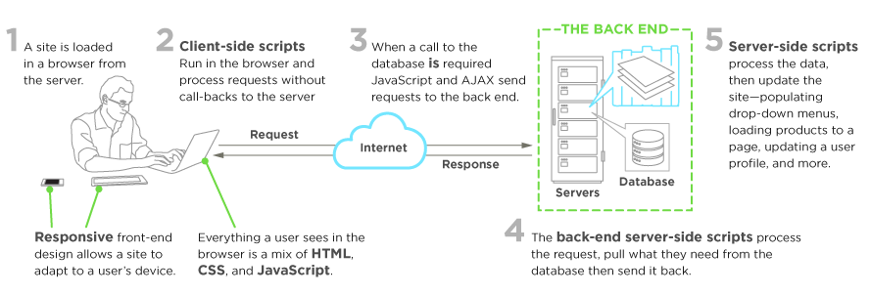

Figure 1.Sequency diagram

* Sitemap

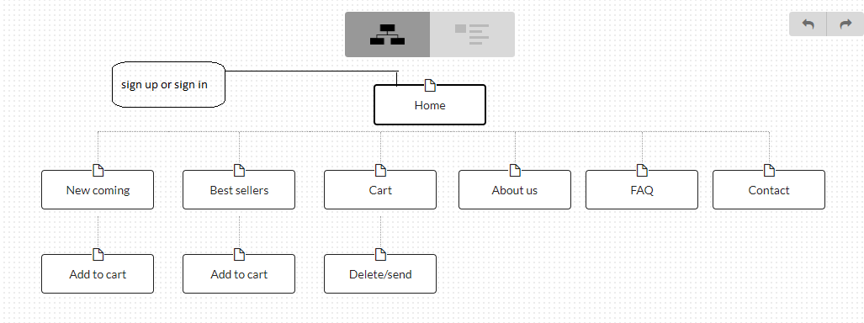

Figure 2.Sitemap

* Wireframe

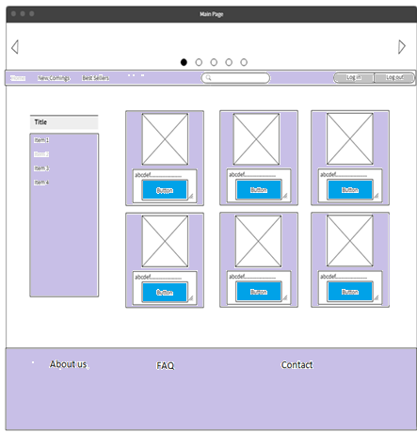

Figure 3. Wireframe of the home page.

This is home page of website.

As you see chosen nuances of white, gray, blue such as ‘#FFFFFF’,

‘#d3d3d3’, ‘#0000ff’, as a background for the body blocks except for footer. For the footer we choose dark grey color like “d3d3d3”, because of like book shelf.

Header has:

1. Site icon
2. “Sign up” and ‘Sign in’
3. Navigation bar
4. Cart

Main contains:

1. Carousel slide image
2. Categories
3. Content
4. Search
5. Select price

Footer has:

1. FAQ
2. About us
3. Contact
4. Map

* Web Design

1. Usability (usability)

2. Qualitative typography

3. Effective use of color

4. Simplicity and clarity

5. Rule 2 seconds (3 clicks)

6. Minimum of text and fonts

8. Design is a derivative of the goal

9. Orientation to the target audience

10. Correct information architecture

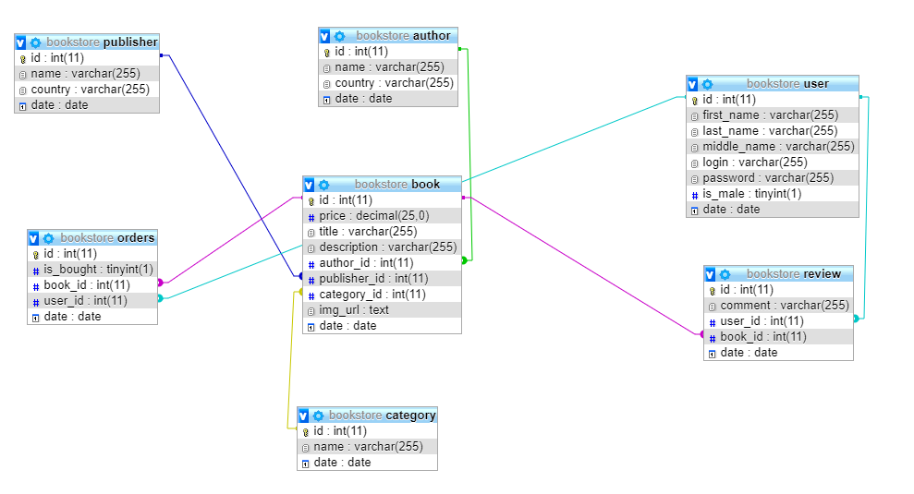

Figure4. Physical database of design.

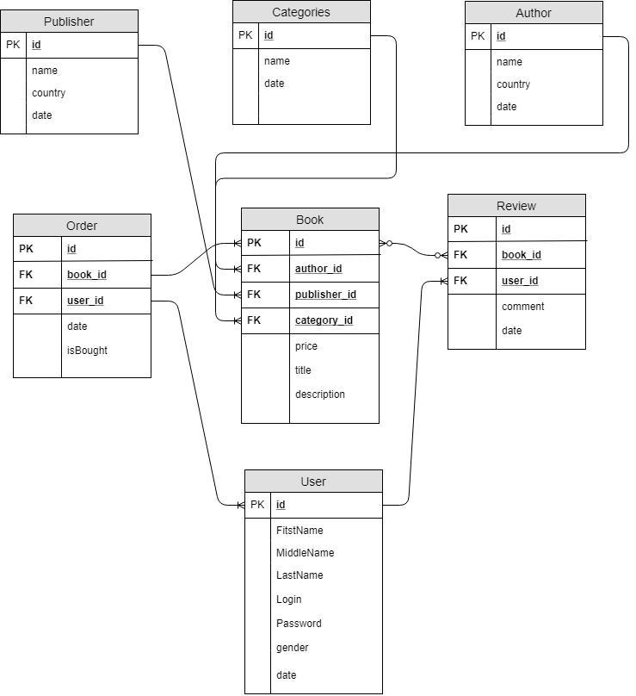

Figure 6. ER diagram

* **Short description for each entity.**

**Book**: It has one primary key (**PK**), and three foreign keys (**FK**) which are it’s about it **publisher, genre and author.** Other threes include information like price, title description.

**Publisher**: It has one PK (**id**) and others about its name and countryside.

**Genre**: It has one PK (**id**) and includes one field about description.

**Author**: It has one PK (**id**) and includes two fields about name and countryside.

**Order**: It has one PK (**id**) and two foreign keys (**FK**) which are it’s about it **book, user.** Other two include information like date, isBought.

**Review**: It has one PK (**id**) and two foreign keys (**FK**) which are it’s about it **book, user.** Other two include information like comment, date.

**User**: It has one PK (**id**) and others include user profile information like FirstName, MiddleName, LastName, Login, Password, gender.

1. Creation

* Web pages

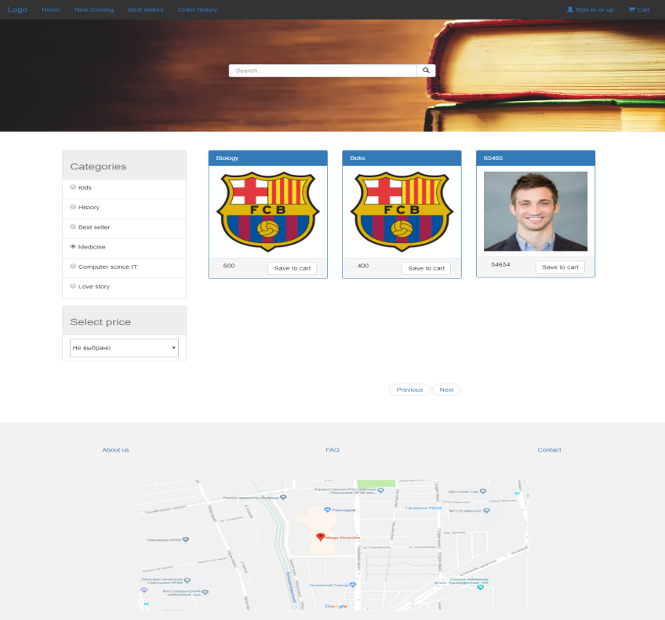

Figure 7. Main page

On this page, user sees all categories of books and user can choose categories, select by price, search book.

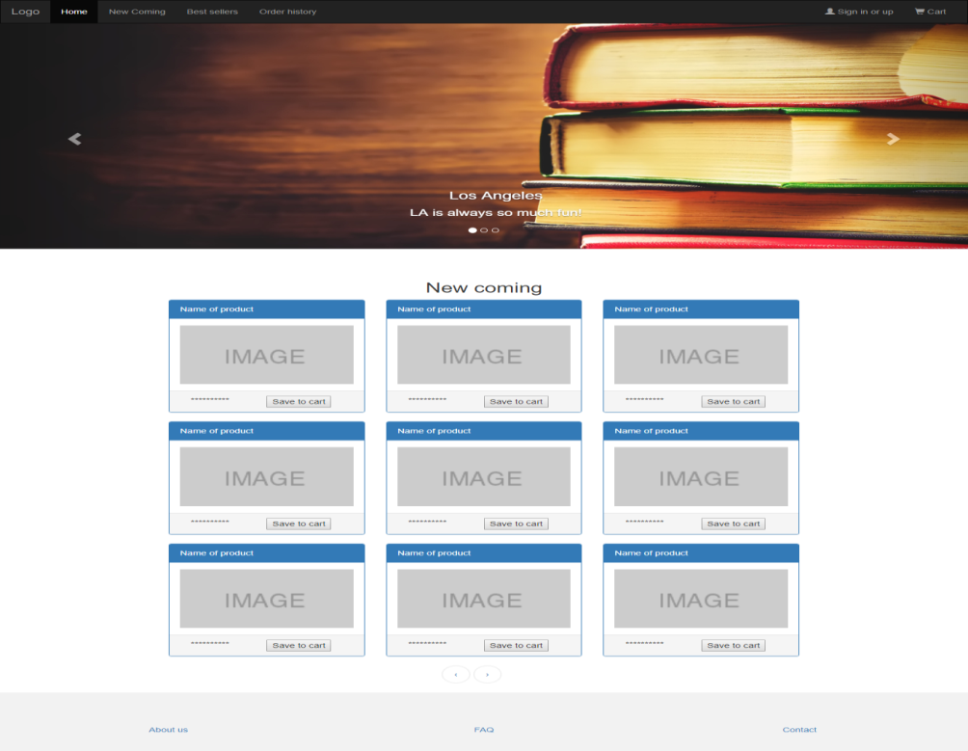

Figure 8. New coming

On this page, user sees new coming of books.

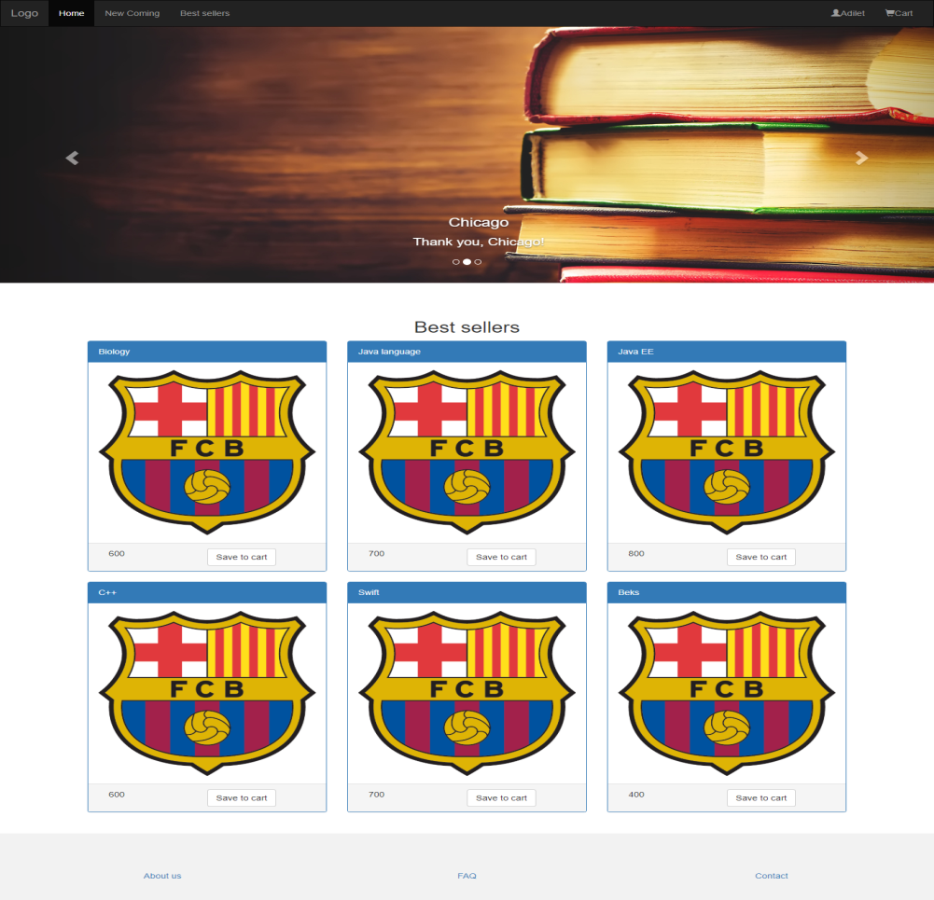

Figure 9. Best sellers

On this page, user sees best books.

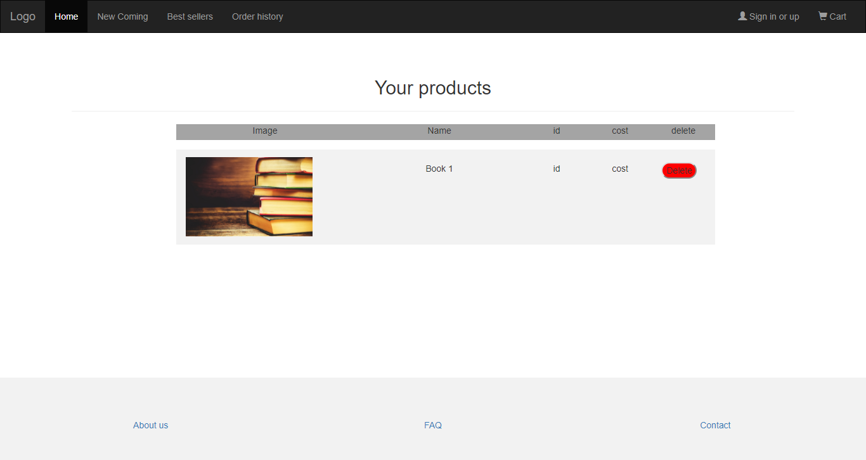

Figure 10.Cart

On this page, user can delete chosen books.

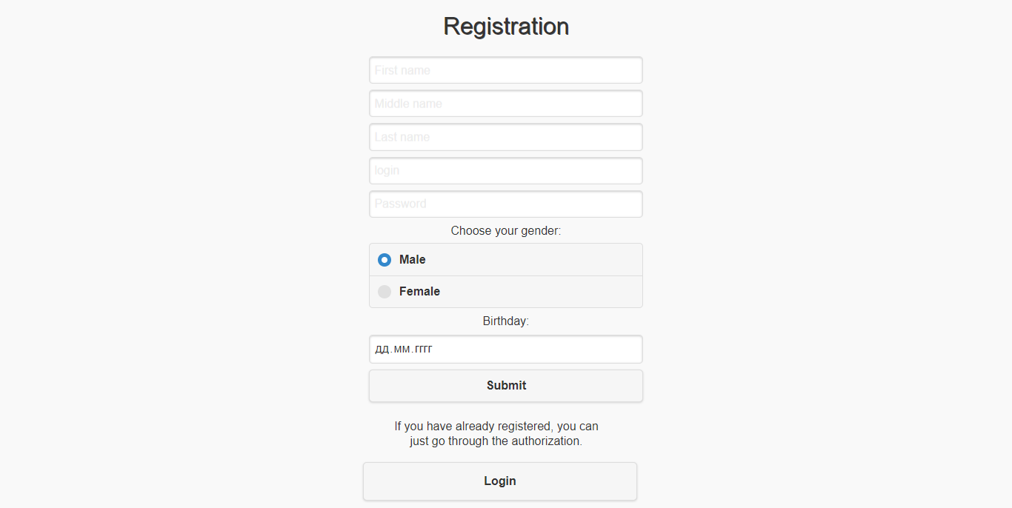

Figure 11. Login or log out

On this page, the user registers to the site or he/she is already registered then choose the authorization.

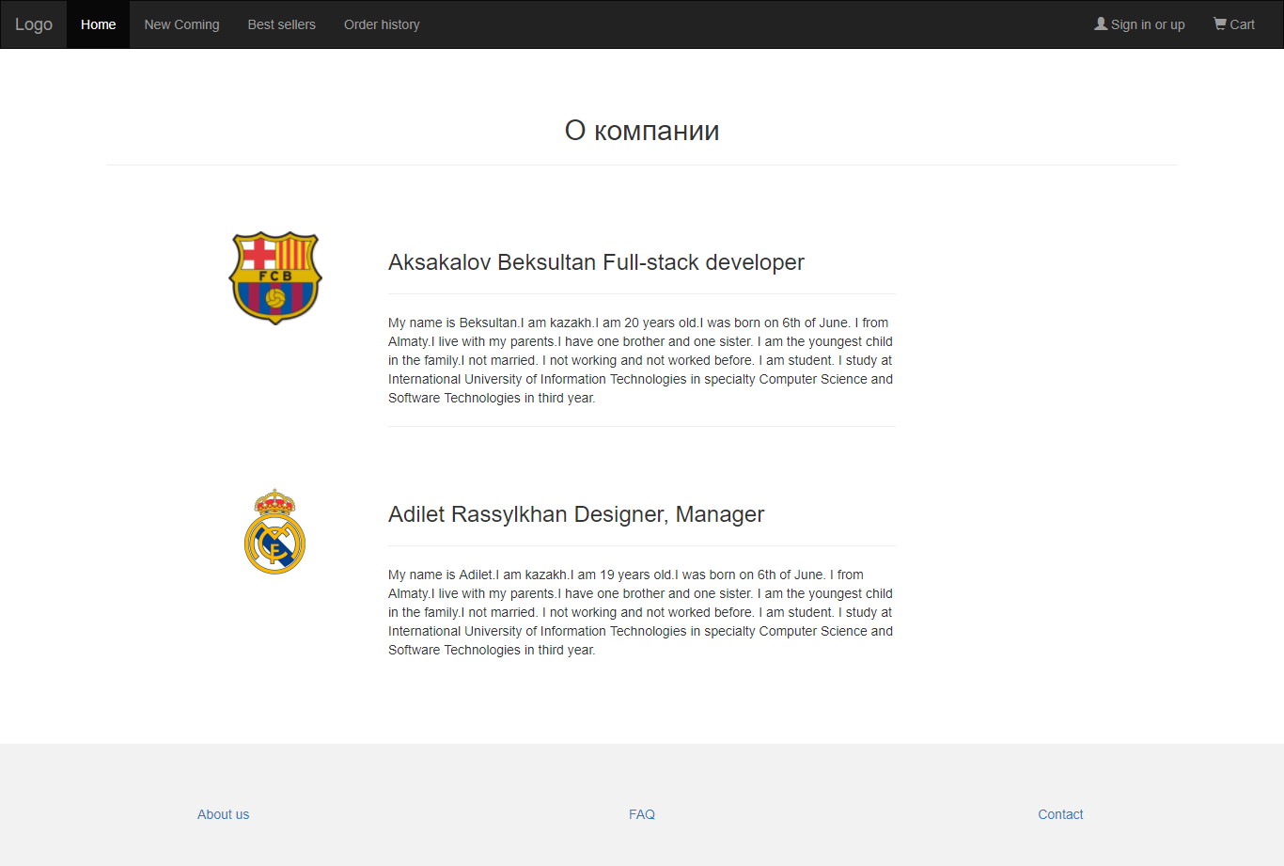

Figure 12.About us

On this page, user sees about developers.

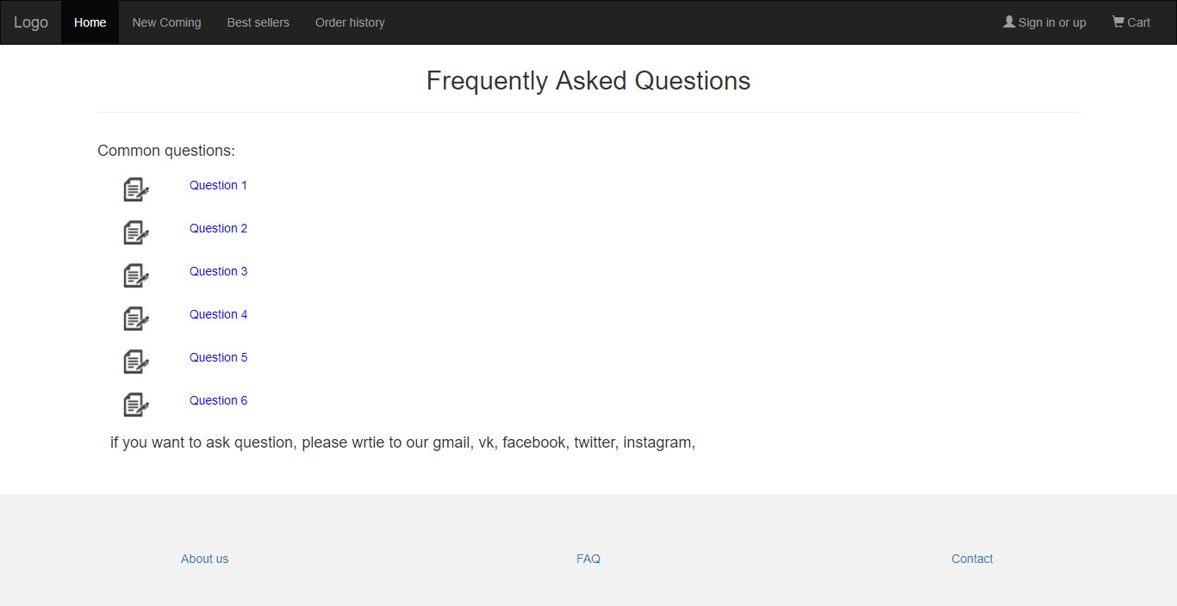

Figure 13. FAQ

On this page, user sees frequently asked questions.

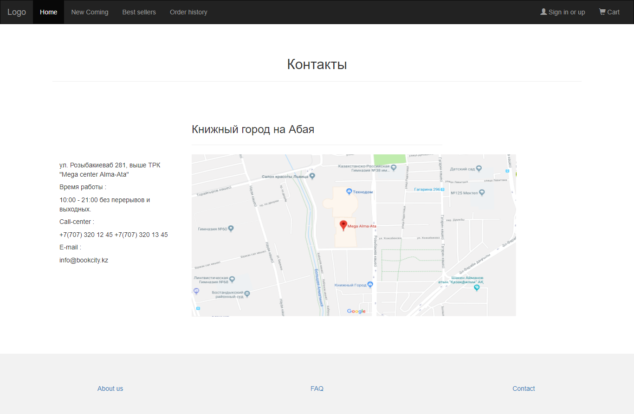

Figure 14. Contact

On this page, user sees contact about our shop.

* Server scripts

1. $servername = "localhost";
2. $username = "root";
3. $password = "root";
4. $dbname = "bookstore";
6. // Create connection
7. $conn = **new** mysqli($servername, $username, $password, $dbname);
9. // Check connection
10. **if** ($conn->connect_error) {
11. **die**("Connection failed: " . $conn->connect_error);
12. }

Figure 14. Connection of database to server

1. $price = $_POST["price"] ?: 1000;
2. $title = $_POST["title"] ?: 'sdf';
3. $author_id = $_POST["author_id"] ?: NUll;
4. $publisher_id = $_POST["publisher_id"] ?: NUll;
5. $category_id = $_POST["category_id"] ?: NUll;
6. $dateT = $_POST["dateT"] ?: date('d.m.Y');
7. $description = $_POST["description"] ?: 'desc';
9. //Set up valid image extensions
10. $extsAllowed = **array**( 'jpg', 'jpeg', 'png', 'gif' );

13. $extUpload = strtolower( substr( strrchr($_FILES['img']['name'], '.') ,1) ) ;
14. //Check if the uploaded file extension is allowed
16. **if** (in_array($extUpload, $extsAllowed) ) {
18. //Upload the file on the server
20. $file_name = "{$_FILES['img']['name']}";
22. $file_path = 'C:\xampp\htdocs\bookstore\Web_project\img';
23. $file_path .= DIRECTORY_SEPARATOR . $file_name;
25. $result = move_uploaded_file($_FILES['img']['tmp_name'], $file_path);
27. } **else** {
28. exit('not_image');
29. }
31. $query = "INSERT INTO `book` (`price`, `title`, `description`, `author_id`, `publisher_id`, `category_id`, `img_url`, `date`) VALUES ('$price', '$title', '$description', '$author_id', '$publisher_id', '$category_id', '$file_name', '$dateT')";
33. $mysqli->query($query);
35. $mysqli->close();
37. header('Location: projects.php');

Figure 15. Adding book to db (Admin part)

* Creation of web database
* --
* -- Структура таблицы `book`
* --
* **CREATE** **TABLE** `book` (
* `id` **int**(11) NOT NULL,
* `price` **decimal**(25,0) NOT NULL,
* `title` **varchar**(255) NOT NULL,
* `description` **varchar**(255) NOT NULL,
* `author_id` **int**(11) **DEFAULT** NULL,
* `publisher_id` **int**(11) **DEFAULT** NULL,
* `category_id` **int**(11) **DEFAULT** NULL,
* `img_url` text,
* `**date**` **date** NOT NULL
* ) ENGINE=InnoDB **DEFAULT** CHARSET=utf8;

Figure 16. Fragment of database creating(“book” table)

Conclusion

The Internet has become a major resource in modern business, thus electronic shopping has gained significance not only from the entrepreneur’s but also from the customer’s point of view. For the entrepreneur, electronic shopping generates new business opportunities and for the customer, it makes comparative shopping possible. As per a survey, most consumers of online stores are impulsive and usually make a decision to stay on a site within the first few seconds. “Website design is like a shop interior. If the shop looks poor or like hundreds of other shops the customer is most likely to skip to the other site”. Hence we have designed the project to provide the user with easy navigation, retrieval of data and necessary feedback as much as possible. In this project, the user is provided with an e-commerce web site that can be used to buy books online. To implement this as a web application we used PHP as the Technology. PHP has several advantages such as enhanced performance, scalability, built- in security and simplicity. PHP: Hypertext Preprocessor (or simply PHP) is a server-side scripting language designed for web development but also used as a general-purpose programming language embedding with HTML, CSS and Javascript. MySQL was used as back-end database since it is one of the most popular open source databases, and it provides fast data access, easy installation and simplicity. A good shopping cart design must be accompanied with user-friendly shopping cart application logic. It should be convenient for the customer to view the contents of their cart and to be able to remove or add items to their cart. The shopping cart application described in this project provides a number of features that are designed to make the customer more comfortable. This project helps in understanding the creation of an interactive web page and the technologies used to implement it. The design of the project which includes Data Model and Process Model illustrates how the database is built with different tables, how the data is accessed and processed from the tables. The building of the project has given me a precise knowledge about how JSP is used to develop a website, how it connects to the database to access the data and how the data and web pages are modified to provide the user with a shopping cart application

References

<http://www.planetb.ca/syntax-highlight-word> - Syntax Highlight Code In Word Documents

<http://getbootstrap.com/docs/3.3/> - I used bootstrap 3 for my web site.

<https://www.w3schools.com/php/php_intro.asp> - PHP

<https://moqups.com/> - Drawing mockup

<https://writemaps.com/> - Drawing sitemap